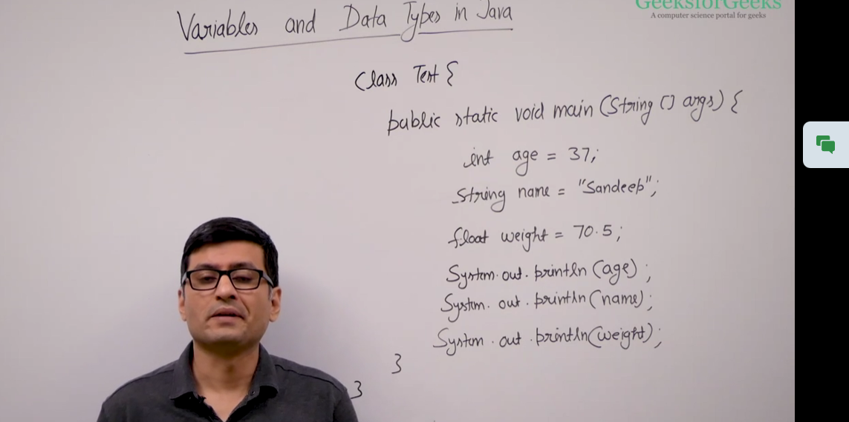
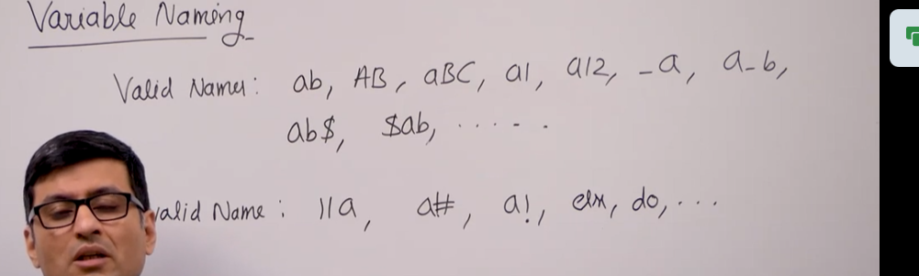

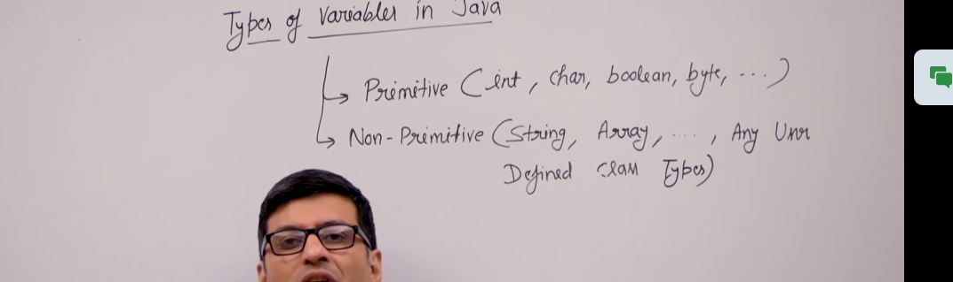
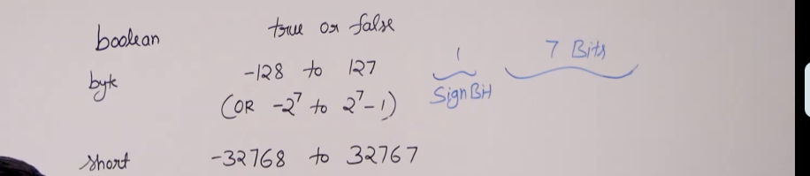

The values that we have written on the right side are called literals. True is a literal, 90 is a literal, 3.14 is a literal, and 15.0f is a literal. The "f" here is used to represent that it is a floating-point value. If you want to store this literal using double representation, you can do so accordingly.
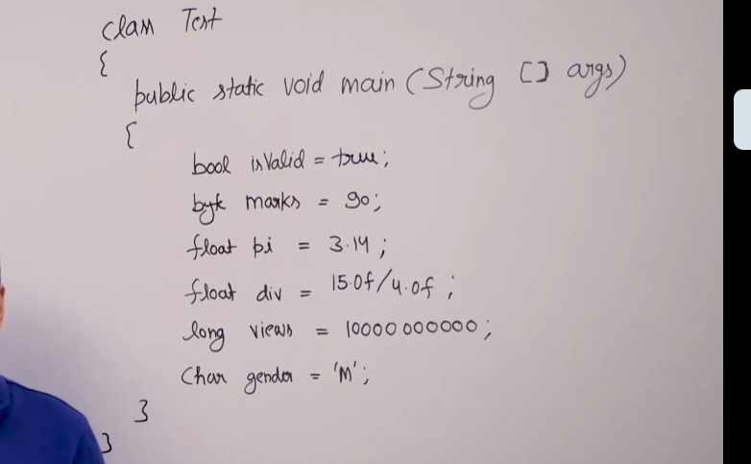
Types are actually classes, and these classes can be user-defined or predefined library classes. For example, System is a predefined library class in Java.
Here's another class, Point, that we have created on our own. This Point class has two members, x and y. So, it's a 2D point that has two members, x and y.
We created an object of this class here, and this object is `p`. The data type that this class creates is a non-primitive data type. Any data type created by classes is a non-primitive data type.
Another class in this code is Test. This is also a non-primitive data type.
We create variables of non-primitive type using the `new` operator.
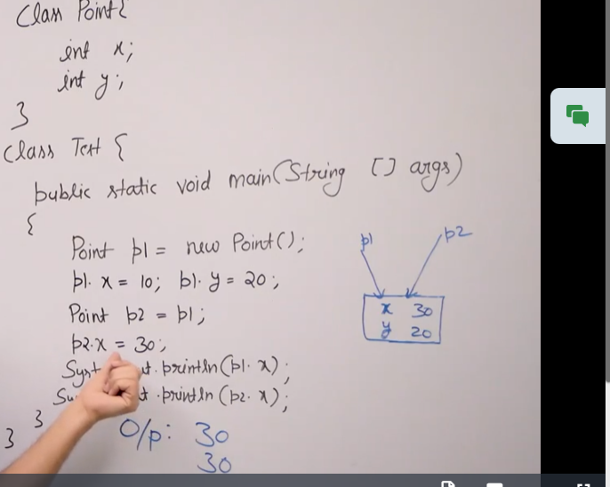
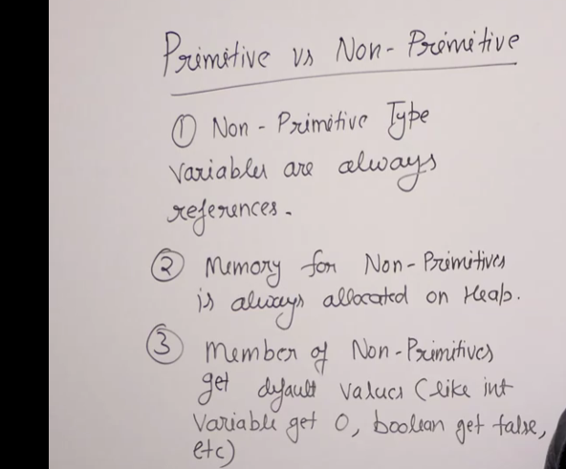
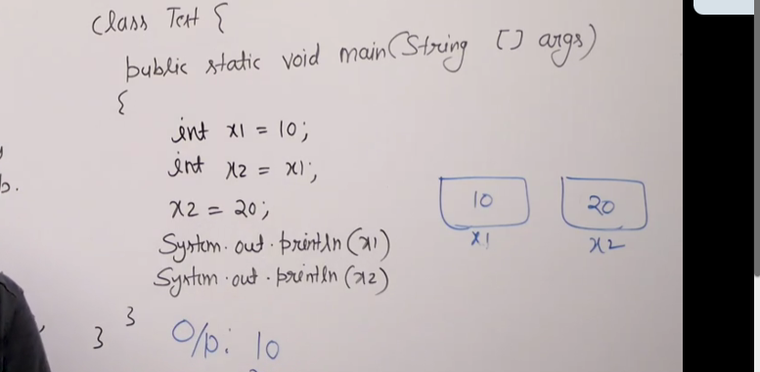
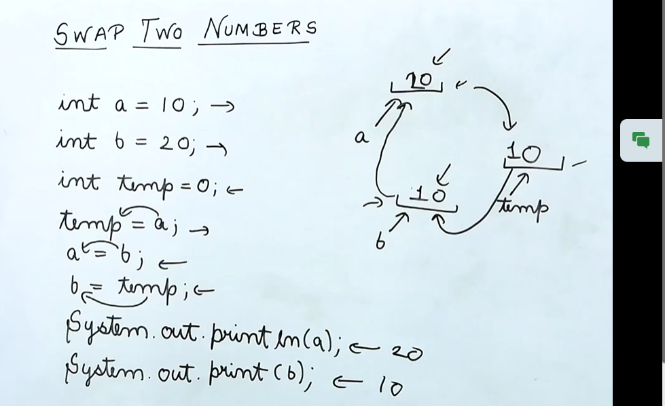
Non-primitive types are created when you define objects of a class. Java allows non-primitive types for every primitive type.
There are built-in classes in Java where each class corresponds to a primitive type. For example, for char, there is the Character class, and for byte, there is the Byte class. All these classes begin with a capital letter.

For every primitive type, there is a corresponding wrapper class that holds a primitive type value.
Here is an example. x1 is a primitive type. When you declare int x1 = 10;, it creates a normal primitive variable.
Now, Integer x2 uses Integer, which is a wrapper class. This creates the x2 variable, and as we discussed earlier, x2 is a reference. So, there is a memory location holding the value 10, and x2 acts as a reference to this location.
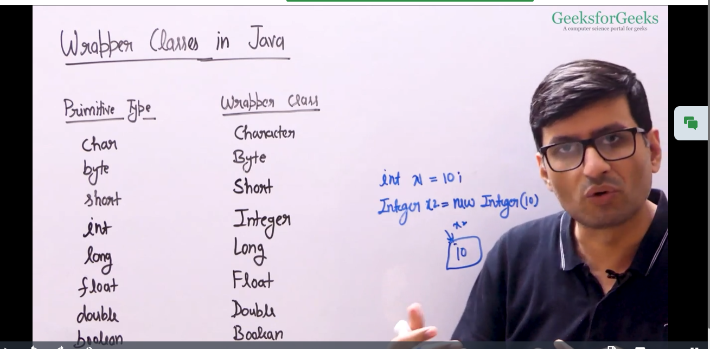

Auto boxing occurs when a primitive type variable is converted into its corresponding wrapper class object. For example, int automatically becomes Integer, and Integer automatically converts back to int. Similarly, char converts to Character, and Character converts back to char.
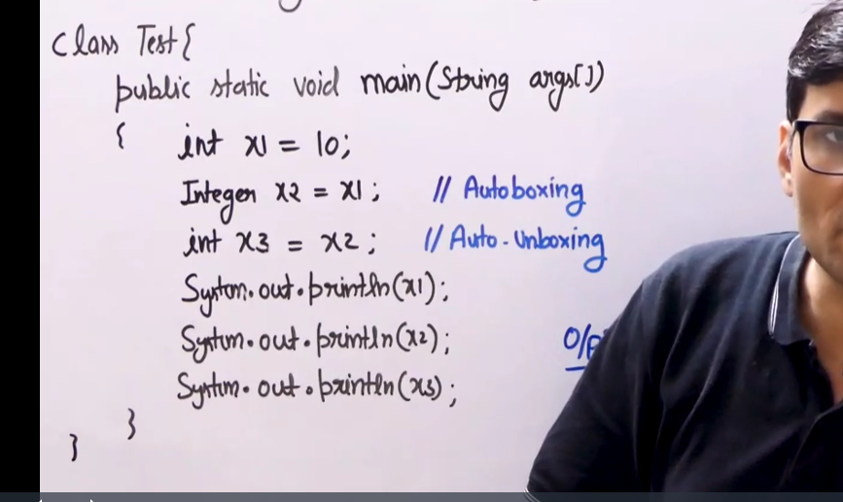

Type casting
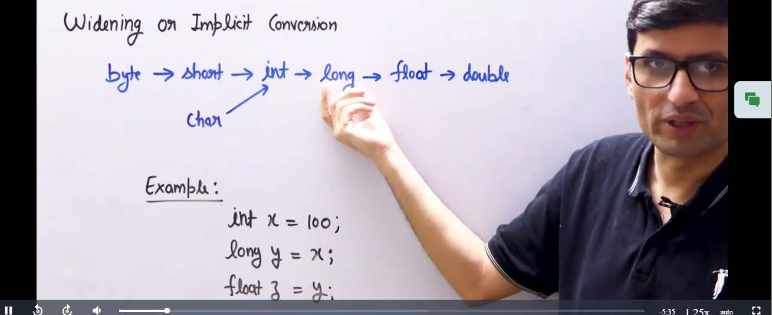
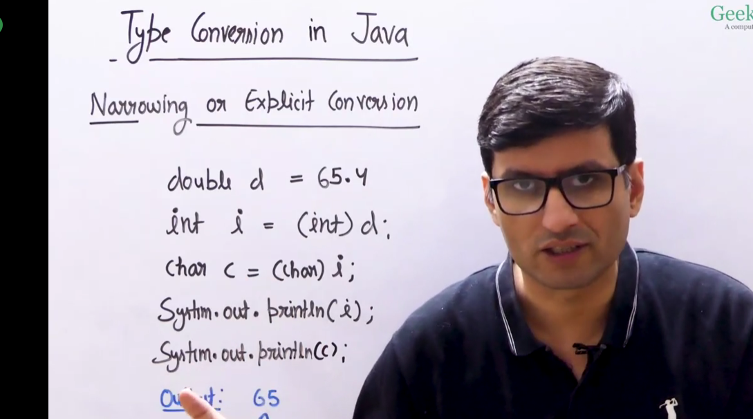

Java Input
BufferedReader is a simple class, which is used to read a character or a sequence of characters


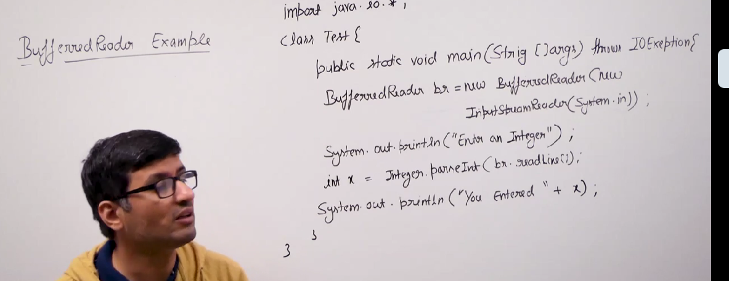
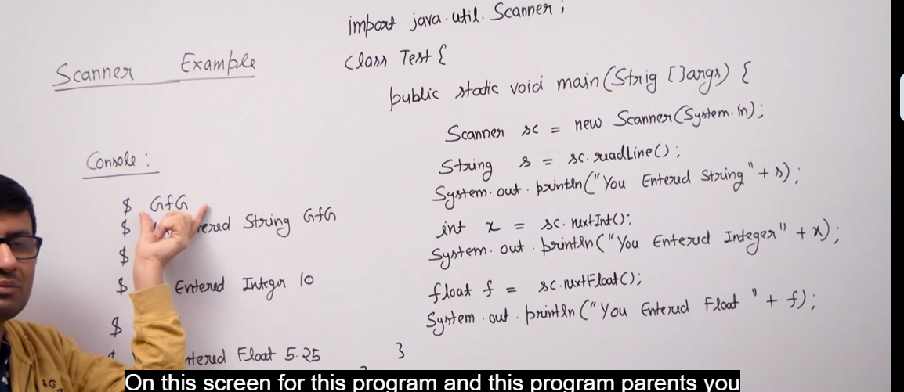

Out Put

"The format function is particularly useful for formatted output. When you have inputs like floating point numbers, dates, or times, this function helps structure them effectively. It is mainly useful for formatting numbers."
